IT lab 200 Sqft 10 computer’s with Ac 
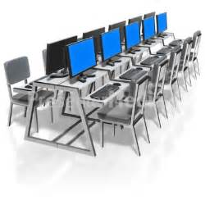
Reception with waiting area 150sqft 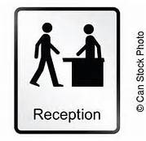

LOGISTIC Job role name Documentation Assistant lab room with 15 computer’s & software 300sqft 


Handicap Toilet with facility sqft 50


Girls Toilet sqft 50

Male Toilet sqft 50

Counseling cell 150 sqft


Placement cell 150sqft

Pantry 100 sqft

Library with 5 book’s related job role 100sqft 


Staff room sq ft 150 sq ft 

LOGISTIC Job role name Documentation Assistant class room 300sqft 


